**The BoJ vs the Markets  
日本央行 vs 市场**

（英文部分选自经济学人20220625期财经版块）

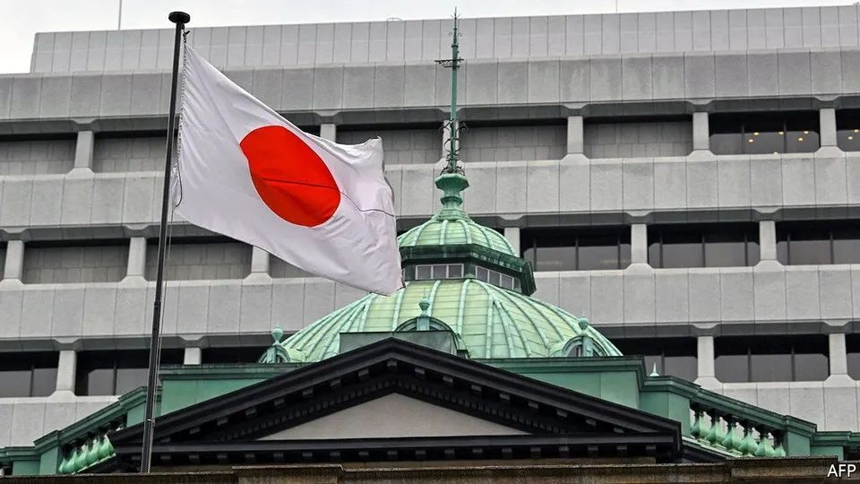

Asian exceptionalism

亚洲例外论

The BoJ vs the Markets

日本央行 vs 市场

Investors test the Bank of Japan’s promise to keep yields low

日本央行保持低收益率的承诺经受投资者考验

Thirty years ago, Britain’s **snap decision** to withdraw from the European Exchange Rate Mechanism made George Soros, a hedge-fund titan, more than $1bn from his short positions against sterling. Hedge funds may not be the financial giants they were in 1992, but some speculators still aspire to “break the bank”, to borrow the phrase used to describe Mr Soros’s bet. This time, it is not the Bank of England but the Bank of Japan that the would-be bank-breakers have their eyes on.

30年前，英国仓促退出欧洲汇率机制(European Échange Rate Mechanism)，做空英镑的对冲基金巨头乔治•索罗斯(George Soros)籍此狂赚逾10亿美元。如今的对冲基金可能已不复1992年之勇，但一些投机者仍渴望“剃银行光头”（人们常这样形容当年索罗斯的豪赌）。只是这次，他们手里的“推子”对准的不是英格兰银行，而是日本央行（Bank of Japan, BOJ）。

**The BoJ stands out like a sore thumb in the world of monetary policy.** While the Federal Reserve, the European Central Bank and the Bank of England are rushing to combat inflation by reversing asset-purchase schemes and raising interest rates, the BoJ is sticking to its guns. After a meeting on June 17th it left its policy of “yield-curve control”, intended to keep yields on ten-year Japanese government bonds at around 0%, firmly in place. As the gulf between Japanese and rising American bond yields has widened, the yen has plunged: by 15% this year so far, to its lowest level against the dollar since the late 1990s.

日本央行在货币政策上可谓特立独行。美联储(Federal Reserve)、欧洲央行(ecb)和英格兰银行(Bank of England)争先恐后地取消资产购买计划并提高利率，以抗击通胀，但日本央行仍岿然不动。6月17日，日本央行召开会议，随后宣布将维持现行的“收益率曲线控制（yield-curve control）”政策。该政策旨在将十年期日本政府债券的收益率保持在0%附近。美国国债收益率走高，拉开了与日本国债之间的差距，日元兑美元汇率因此大幅下跌:今年以来已经下跌了15%，创出上世纪90年代末以来的最低水平。

The BoJ adopted **yield-curve control** in 2016 as a way to maintain monetary stimulus, while slowing down the frenetic purchases of Japanese government bonds that it had been undertaking since 2013 to boost inflation. For most of the time its yield cap has been in place, the mere promise to buy more bonds if anyone tested its resolve was enough to keep **a lid on** yields. More recently, however, that commitment has itself been tested. **In the five days to June 20th** the central bank was forced to buy government bonds worth ¥10.9trn ($81bn) as it sought to **suppress** yields. **By contrast**, between 2015 and 2021 it never bought more than ¥4trn in a five-day period.

日本央行从2016年开始实施“收益率曲线控制”政策，以期维持货币刺激，同时放缓了自2013年以来为推高通胀而疯狂购买日本国债的做法。在控制收益率上限的大部分时间里，如果有人想“以身试法”，央行只消承诺买入更多债券，收益率就能被牢牢压住。然而最近，日本央行的承诺受到了考验。6月16-20日的5天里，日本央行被迫购买了10.9万亿日元(约合810亿美元)的国债，以求抑制收益率。相比之下，2015-2021年间，日本央行在5天时间内买入国债的数额不曾超过4万亿日元。

Some investors are betting that the BoJ will eventually be forced to alter, or even abandon, its target. BlueBay Asset Management, an investment firm with more than $127bn in assets as of September 2021, is short-selling Japanese government debt. Mark Dowding, the firm’s chief investment officer, has called the central bank’s position “untenable”. Volatility in the typically calm Japanese government-bond market has surged to its highest level in more than a decade.

一些投资者押宝日本央行最终将被迫更改、甚至放弃其收益率目标。蓝湾资产管理（BlueBay Asset Management，截止2021年9月，该公司拥有超过1270亿美元资产）就是其中之一：这家投资公司正在做空日本国债。该公司首席投资官马克·道丁（Mark Dowding）称日本央行“无力维持其现行政策”。日本国债市场一向平稳，但如今其波动程度已达十多年来的最高水平。

The investors betting against the BoJ might be **taking hope from** moments when central banks abandoned similar commitments. Late last year the Reserve Bank of Australia’s yield-curve control policy, which targeted three-year Australian government bonds, collapsed spectacularly as yields surged and the central bank failed to defend its target. The Swiss National Bank insisted it would not break its currency peg to the euro in the months leading up to January 2015, before doing precisely that.

历史上不乏央行放弃类似承诺的例子，与日本央行对赌的投资者们可能从中看到了希望。去年晚些时候，澳大利亚储备银行（Reserve Bank of Australia）的收益率曲线控制政策轰然倒塌。该政策旨在控制三年期国债的收益率，但最终国债收益率飙升，该行也没能力挽狂澜。2014年的最后几个月里，瑞士国家银行（Swiss National Bank）一直坚称瑞士法郎不会与欧元脱钩。但2015年甫一开年，该银行就“真香”了。

So far, however, neither Japan’s economy nor the central bank’s internal dynamics hint that a change in policy is coming. Inflation has risen, but not **exploded as** in other parts of the world; consumer prices rose by 2.5% in the year to April, compared with 8.3% in America. Excluding **fresh food** and energy, **Japanese prices are still up by less than 1% year-on-year, and wages by less than 2%.** There is little sign of domestically generated price growth.

然而，迄今为止，日本经济和日本央行内部动态都没有显露出政策转变的征兆。通货膨胀已然走高，但并未像世界其他地方那样一发不可收拾。今年1-4月，日本的居民消费价格上涨2.5%，而美国的这一数字为8.3%。除去生鲜食品和能源，日本价格同比上涨不到1%，工资增长不到2%，鲜有内生型通胀的迹象。

**The weak yen, meanwhile, has a mixed effect.** It **drives up** imported inflationand magnifies the effect of rising dollar-denominated oil prices. But after many years in which Japan’s price level has barely budged, **a shallow increase** does not seem an urgent threat. Even with all these **external shocks**, inflation is barely above the central bank’s target of 2%. Rapid moves in the currency make planning difficult for businesses, but a weaker exchange rate benefits many exporters of manufactured goods, as well as the holders of Japan’s ¥1.2 quadrillion in overseas assets, which have gone up in yen terms.

与此同时，疲软的日元令人忧喜参半。它推高了输入型通胀，也放大了油价上涨的影响（全球石油几乎都以美元计价）。但是，多年来日本的价格水平几乎一成不变，小幅上涨看上去并非迫在眉睫的威胁。即使遭受了如此多的外部冲击，通货膨胀也才略高于央行2%的目标。日元的快速波动令企业难以做出规划，但疲软的汇率却让许多工业制成品出口商和海外资产持有者受益——日本海外资产超过1200万亿日元，以贬值的日元计价，这些资产升值了。

Nor does the mood within the BoJ so far hint at a coming change in policy. The central bank still has several monetary doves in its roosts. Kataoka Goushi was **the sole board member** to vote against holding policy unchanged in June, but because he wanted even more stimulus, not less. In early June Wakatabe Masazumi, the bank’s **deputy governor**, said that **monetary easing** should be pursued to maintain wage growth. And Kuroda Haruhiko, the governor of the BoJ, is **a longtime advocate of** monetary stimulus to revive Japan’s **sluggish economic growth**.

日本央行内部也没有改变现行政策的想法。央行内部仍有不少货币政策鸽派。六月的会议上，片冈刚士(Kataoka Goushi)是唯一反对维持现行政策的董事会成员，然而他想要的是加大货币刺激，而非减少。6月初，副行长田部昌澄（Wakatabe Masazumi）表示，应推行宽松的货币政策以维持工资增长。而行长黑田东彦(Haruhiko Kuroda)长期以来一直主张通过货币刺激来重振日本低迷的经济增长。

**Mr Kuroda is now into the final year of his term.** His replacement may well be Amamiya Masayoshi, another deputy governor, who **is so entrenched in** the institution that he is known as “Mr BoJ”. Mr Amamiya has sometimes been seen as more hawkish than Mr Kuroda. But in his most recent comments on monetary policy, in mid-May, he spoke **in favour of** continuing current policy without reservations. Barring a change to **the domestic picture**, or a groundswell of hawkish sentiment within the BoJ, investors expecting a u-turn are likely to be disappointed.

如今，黑田东彦的任期已到了最后一年。他的继任者可能是另一位副行长雨宫正义（Masayoshi Amamiya），其地位在央行根深蒂固，人称“日本央行先生”（“Mr boj”）。在许多人眼中，雨宫正义比黑田东彦更偏向鹰派。然而，最近一次就货币政策发表言论时（5月中旬），他表示自己毫无保留地支持现行政策。除非日本国内形势有变，或者日本央行内部的鹰派情绪高涨，期待政策出现180度大转弯的投资者们很可能会大失所望。